*Shaik Taineyath Bsc(bzc)*

***Final project***

***1)Comprehensive digitalmarketing for ptron***

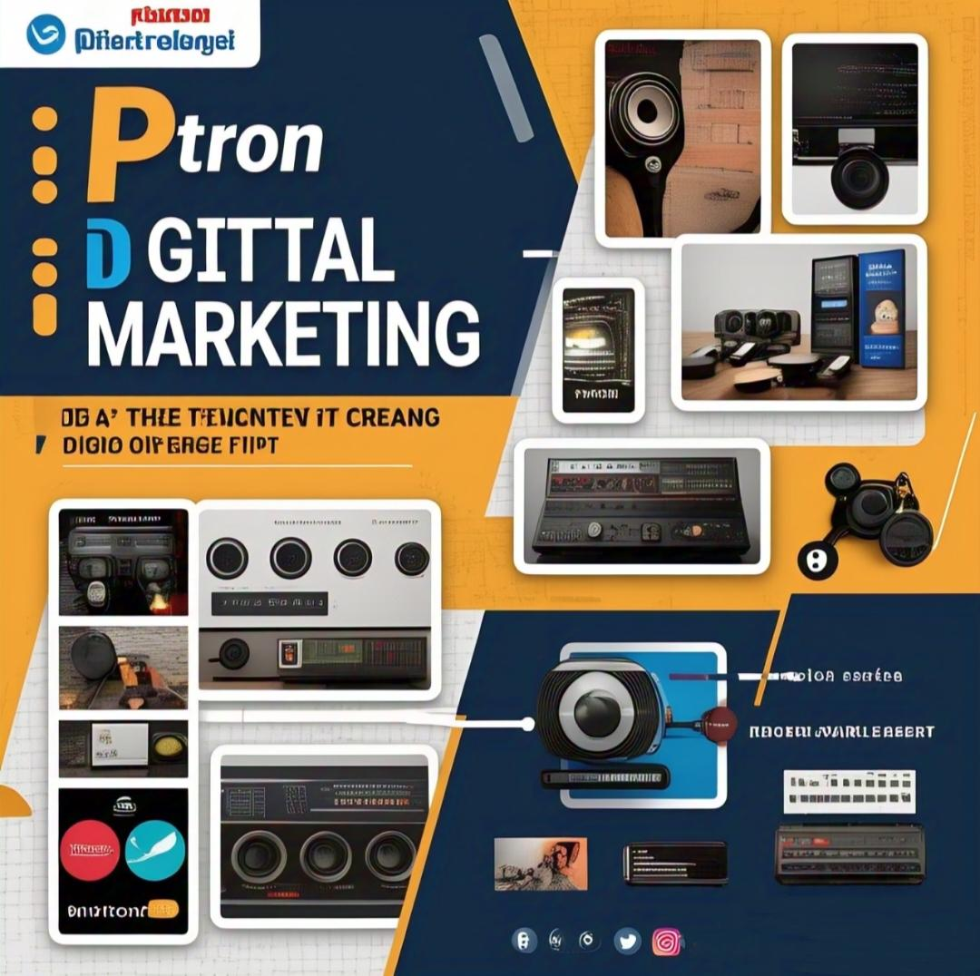

Project description:-

PTron, a leading player in the consumer electronics industry, he set to revolutionize it's digital marketing strategy to amplify its brand presence and engage with its target audience more effectively.Leveraging a comprehensive approach, ptron AIIMS to harness the power of various digital channels to established itself as a household recommendations tailor to individual preferences.

As Google ads and social media, will be meticulously crafted to reach specific demographics and capitalise on high- intent searches, ensuring maximum return on investment (ROI) with a robust digital marketing strategy in place, ptron is poised to cement its position as a front runner in the competitive consumer electronics market, driving growth and fostering brand loyalty in the digital age.

2) ***Brand study / Research:-***

✓ *Online research:*

*Ptron website:-

* Visual identity ( logo ,Colors scheme,typography)
* Tone and voice
* Product offerings
* User experience

✓*social media:-*

* Facebook through [http: //facebook.com ptron India.](http://facebook.com)
* Instagram through [http://i](http://inshallah)[nstagram.com/ptron India.](http://nstagram.com/ptron)
* Twitter:(link unavailable) or <http://twitter.com>.
* Analyser content strategy, engagement,and visual identity
* Blogs,video content, content calendar platform optimization, influencer partnership ,email marketing ,news letters,welcome emails, abandoned cart emails.

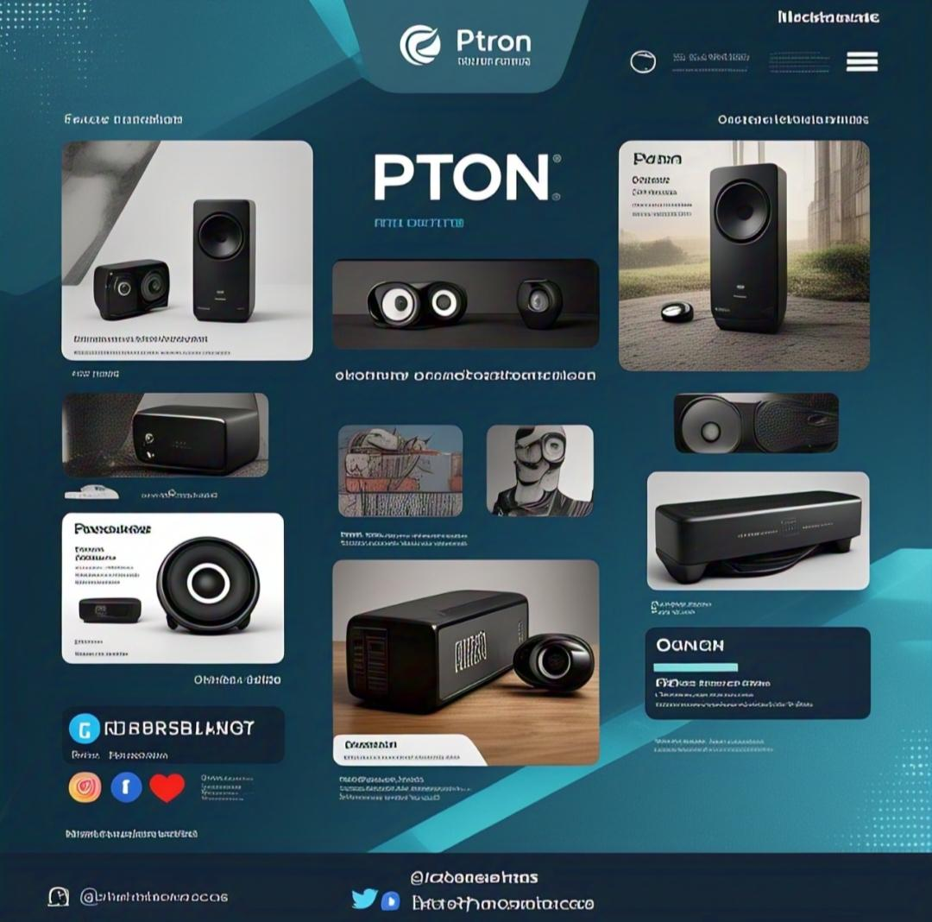

✓***Google search:-***

* Ptron’s search engine rankings
* Online reviews and ratings
* News articles and press release
* Look for paid advertising like Google ads,native ad, social media ads.

***\*Competitor analysis:-***

✓*Identify competitors:*  Research ptron’s competitor in the electronics industries such as

*Boat

*JBL

*Sony.

•Boost website traffic by 50%

•Generate 20% more sales through the website and online market places. 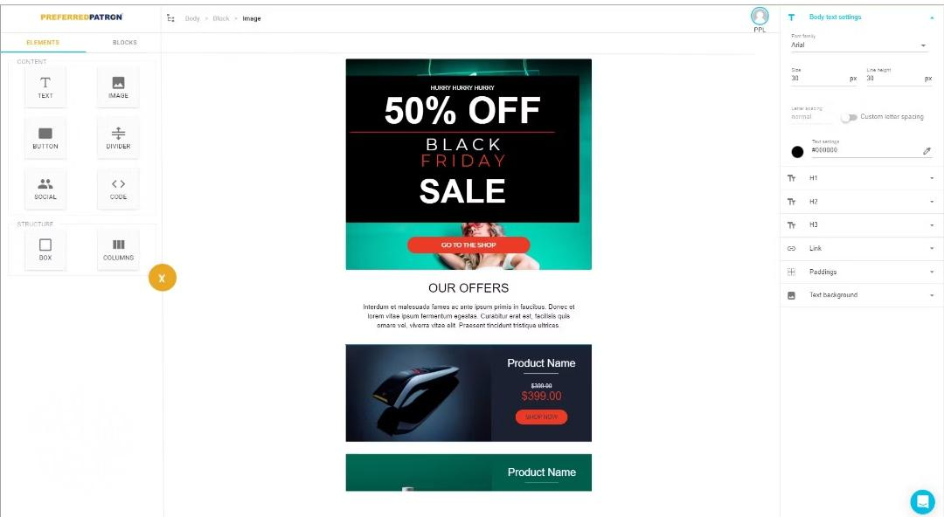

✓*Competitor website analysis:-* Analyze competitors website, social media and content strategies.

✓*Market Gap Analysis:-* Identify gaps in the market that ptron can fill. Ptron's target audience, market overview ,unique selling proposition (USP)

\**Customer Insights:-*

✓Customer Reviews:-Analyse customer reviews on ptron website, social media and review platform like trust pilot.

✓Social Media Listening:-Monitor social media conversations about ptron and its competitors.

✓Surveys and feedback:- Conduct Surveys or gather feedback from ptron's customer to understand their needs and preferences.

\**Brand identity elements:-*

✓Logo:-Analyse ptron's logo, including its design, colour scheme and typography

✓colour palette:- Identify ptron's primary and secondary colour schemes.

✓Typography:- Analyse ptron's font style and usage.

✓Imagery:- Examine ptron's image styles,including photography and graphics.

✓Tone and Voice:- Identify ptron's tone and voice across different marketing channels.

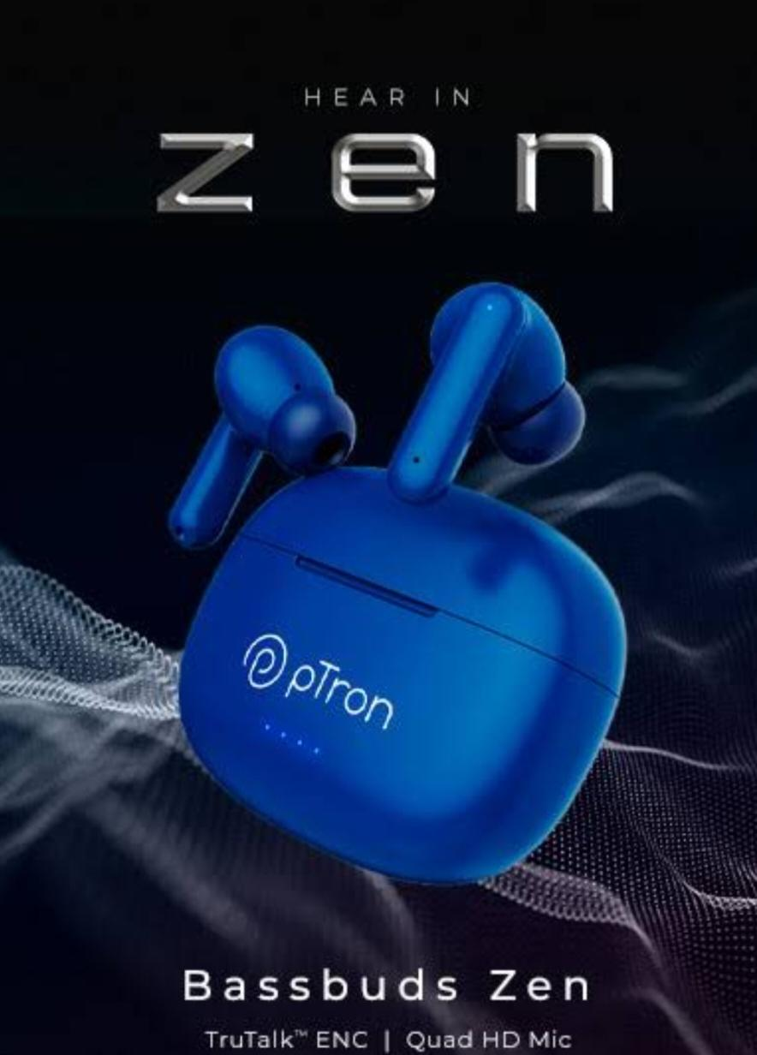

*Tools and Resources:-

1)SEM rush:- Use sem rush to analyse ptron's website, competitors ,and keyword strategy.

2)Ahrefs:-utilise Ahrefs to analyse ptron's backlinks content strategy and keyword ranking.

3) Hoot suite Insights:-Use Hootsuite Insights to analyse ptron's social media presence and performance.

4)Canva Design:- Utilize canvas design to analyse ptron's visual identity and branding.

\**Research Report:-*

1) Compile Findings:-compile research findings into a comprehensive report.

2) visual identity:-include and analysis of ptron's visual identity ,including logos ,colour palettes, typography and imagery.

3) tone and voice:-analyse ptron's tone and voice across different marketing channels.

•provide recommendation for improving ptron's brand identity.

***3) SEO and keyword research:-***

✓SEO Audit:-

*Website crawling:-use tools like ahrefs to crawl ptron's website and identify technical SEO issues.

*Keyword research:-conduct keyword research using tools like Google keyword planner, ahrefs,or have sem rush to identify relevant keywords.

*Content analysis:-analyse ptron's website content, including page titles, descriptions, headings and body copy.

*Link analysis:-analyse ptron's back link profile, including anchor text, link equity and toxic links.

*Technical SEO:- identify technical SEO issues, such as page speed, mobile responsive and XML sitemap robots.txt;

✓keyword research:-

* ***keyword ranking tool***:-
* Use keyword research tools to identify relevant keywords, including long tail keywords and phrases.
* Analyse ptron's competitors keywords and identify gaps in the market.
* ***Keyword clustering:***-group keywords into clusters based on relevance and intent.
* Prioritize keywords based on relevance search volume and competition.

✓On-page optimization:-

*Optimize page titles:-write unique, descriptive and keyword rich page titles.

*Optimize meta descriptions:-write compelling and keyword rich meta descriptions.

*Optimize headings:-use header tags {h1- h6} to structure and highlight important content.

*Optimize content:-write high quality engaging and keyword rich content.

*Optimize images:- optimize images by adding alt tags, descriptive text, and compressing images.

*Internal linking:- use internal linking to help users and search engined navigate the websites.

*Mobile friendliness:- ensure the website is mobile friendly and responsive.

***4) content ideas and marketing strategies:-***

✓Content ideas generation and strategy:-

\***Product reviews:**-induct reviews of ptron's audio and mobile accessories.

\***Tech tips and tricks**:- block posts and videos sharing useful tips on using ptron products and solving common tech issues.

\***Industry trends**:-articles and infographics highlighting the latest trends in the electronics and accessories industry.

\***Lifestyle content**:-blog post and social media content showcasing how ptron products fit into everyday life such as a workout playlist or travel accessories.

\***Product comparisons**:-comparative reviews of ptron's product v/s competitors.

\***Behind the scenes:-** content showcasing ptron design process, manufacturing and company culture.

\***Customer testimonials:**-user-generated content featuring satisfied customer sharing their experience with ptron products.

\***Gaming content**:-sponsored content and product reviews targeting gamers highlighting ptron's gaming accessories.

\***Product unboxing**:-unboxing videos and blog post showcasing new ptron products.

\***How to guide**:-step by step guides on using ptron products, trouble shooting , and maintenance.

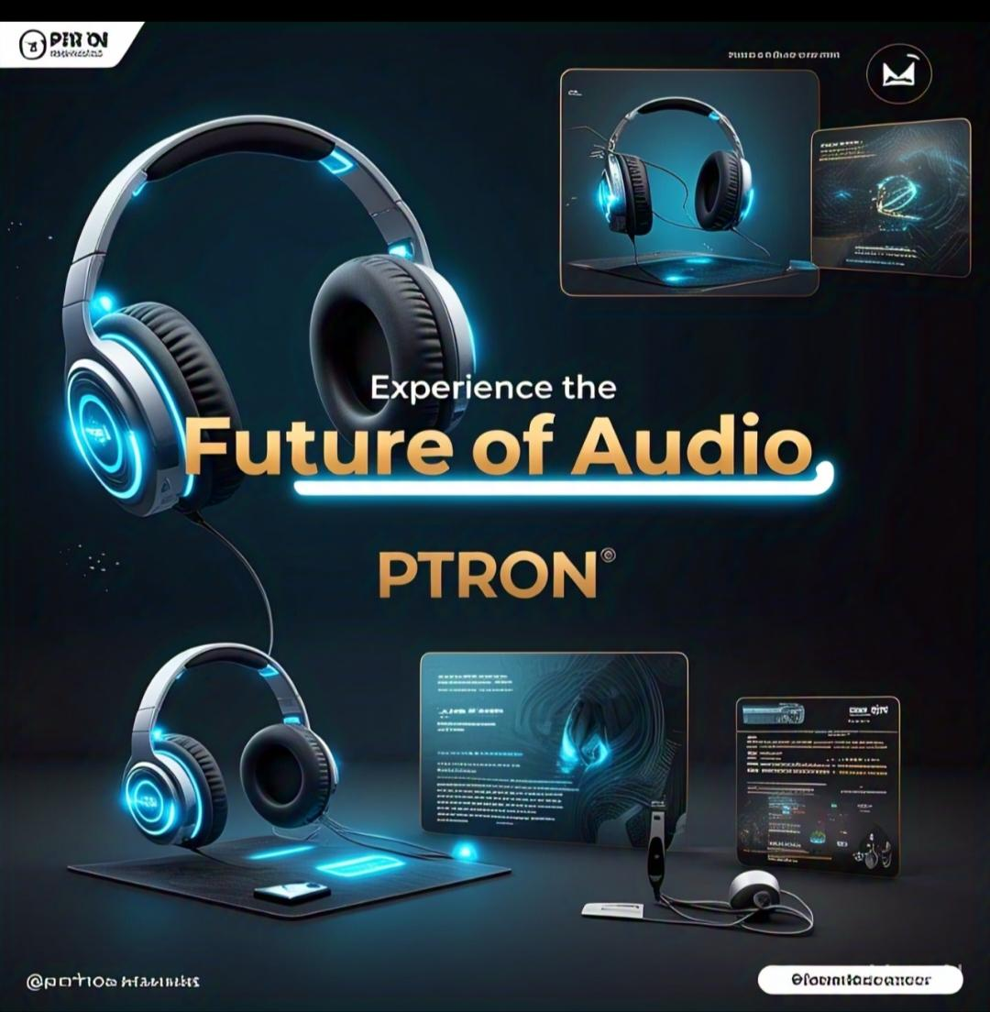

✓content Idea generation and strategy:-

\***Identify target audience:-** understand ptron target audience, including demographics, interest and pain points.

\***Conduct keyword research:-** research relevant keywords and phrases to inform content creation and optimization.

\***Create a content calendar:-** plan and schedule content in advance using a calendar, ensuring consistency and organization.

\***Collaborate with influences:-** partner with influencer and content creators to generate sponsored content and product reviews.

\***Repurpose and update content:-** breath new life into existing content by updating re- purposing and reformatting it for different channels.

\***Utilize user generated content:-** encourage customers to share their experiences ,photos and videos featuring ptron product.

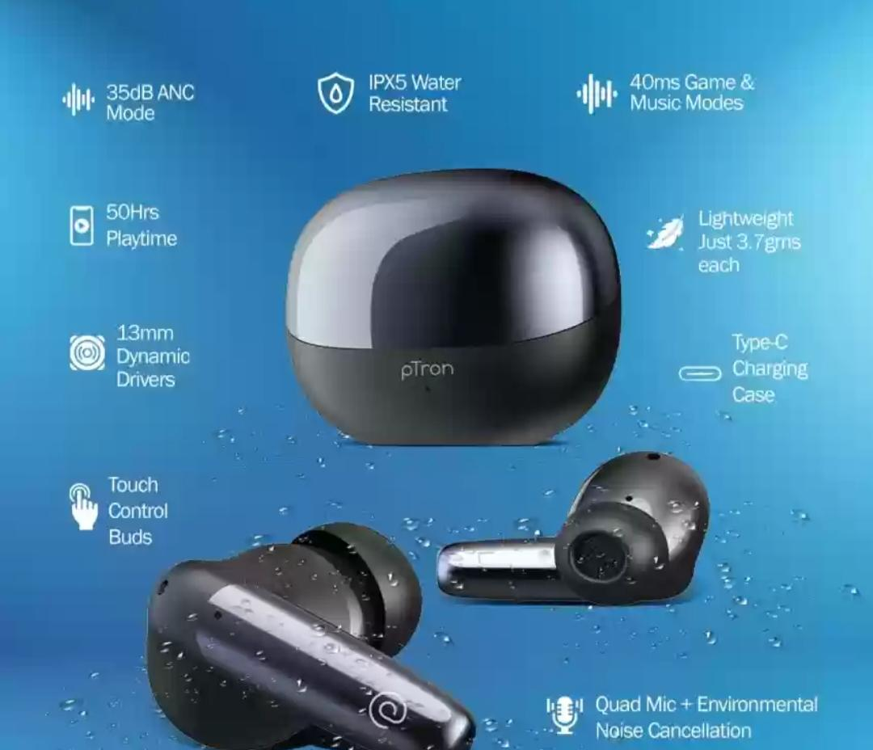

\***Invest in high quality visuals:-** high quality images videos and graphics to enhance content and make it more engaging.

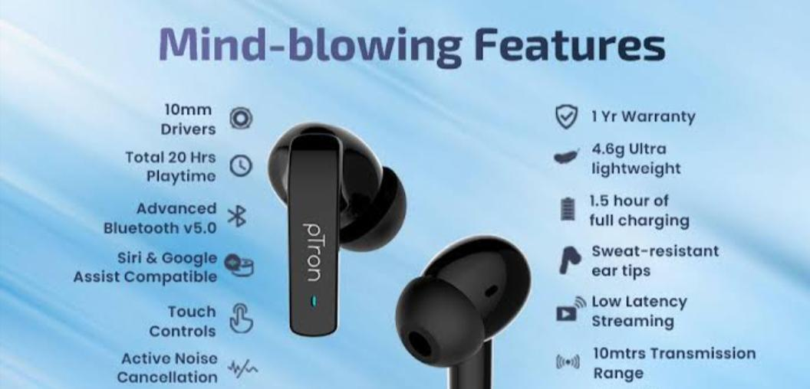

***✓marketing strategies:-***

\***Social media marketing:-** leverage platforms like Facebook, Instagram,Twitter and LinkedIn to share content,engage with the audience and run targeted ads.

\***Influencer marketing:-** partner with influencer and content creators to promote ptron's products and reach new audience.

\***Email marketing:-** build an email list and create regular news letters to share news promotions and product launches with subscribers.

\***Content marketing:-** focus on creating high quality engaging content to attract and retain a clearly define audience.

\***Paid advertising:-** run targeted Google ads, social media ads, and native ads, to reach potential customers and drive website traffic.

\***SEO optimization:-** ensure ptron's website and content or optimized for search engines to improve visibility and drive organic traffic.

\***Referral marketing:-** implement a referral program to incentivize customer to refer friends and family to ptron's product.

\***Loyalty program:-** develop a loyalty program to reward repeat customers and encourage retention.

\***Partnership and collaboration:-** partner with complimentary brands, influencers and content creators to expand reach and offer exclusive products or services.

\***Analytics and tracking:-** monitor and analyse website analytics, social media metrics, and email marketing performance to inform future marketing strategies.



***5) Content Creations and Curation:-***

✓content creation:-

\***Blog posts:-**

* ***Title:-*** 10 ways to upgrade your mobile gaming experience.
* **Content:-** tips and tricks on how to enhance Mobile gaming with ptron accessories.
* **Image:-** a high- quality image of a gamer using ptron accessories.

\***Social media post:-**

•**post-1:-** “new arrival! Introducting our latest wireless earbuds”.

•**image:-** a high-quality image of the new ear buds.

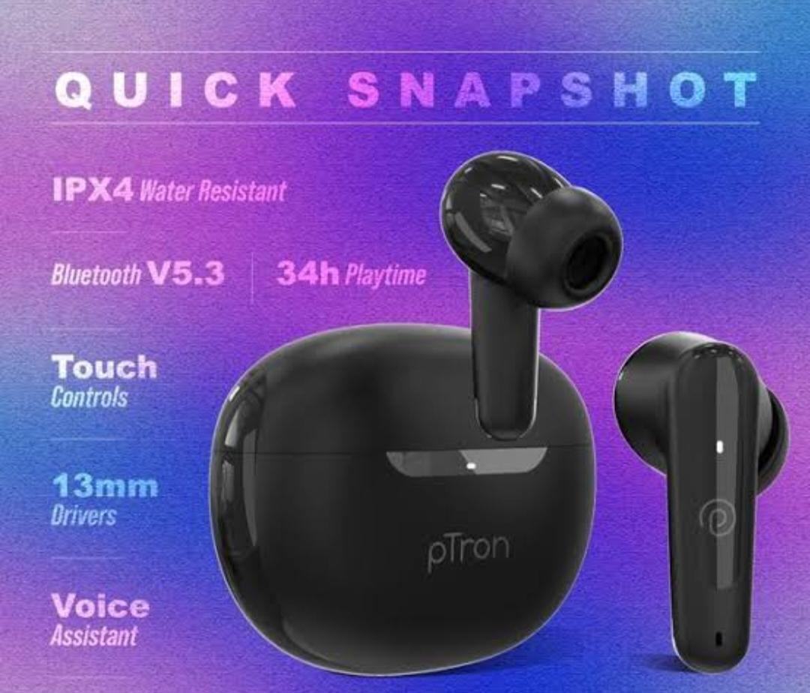

•**post-2:-** “did you know? Our power banks can charge your phone up to 5 times”.

•**image:-** an infographic highlighting the future of ptron's power banks.

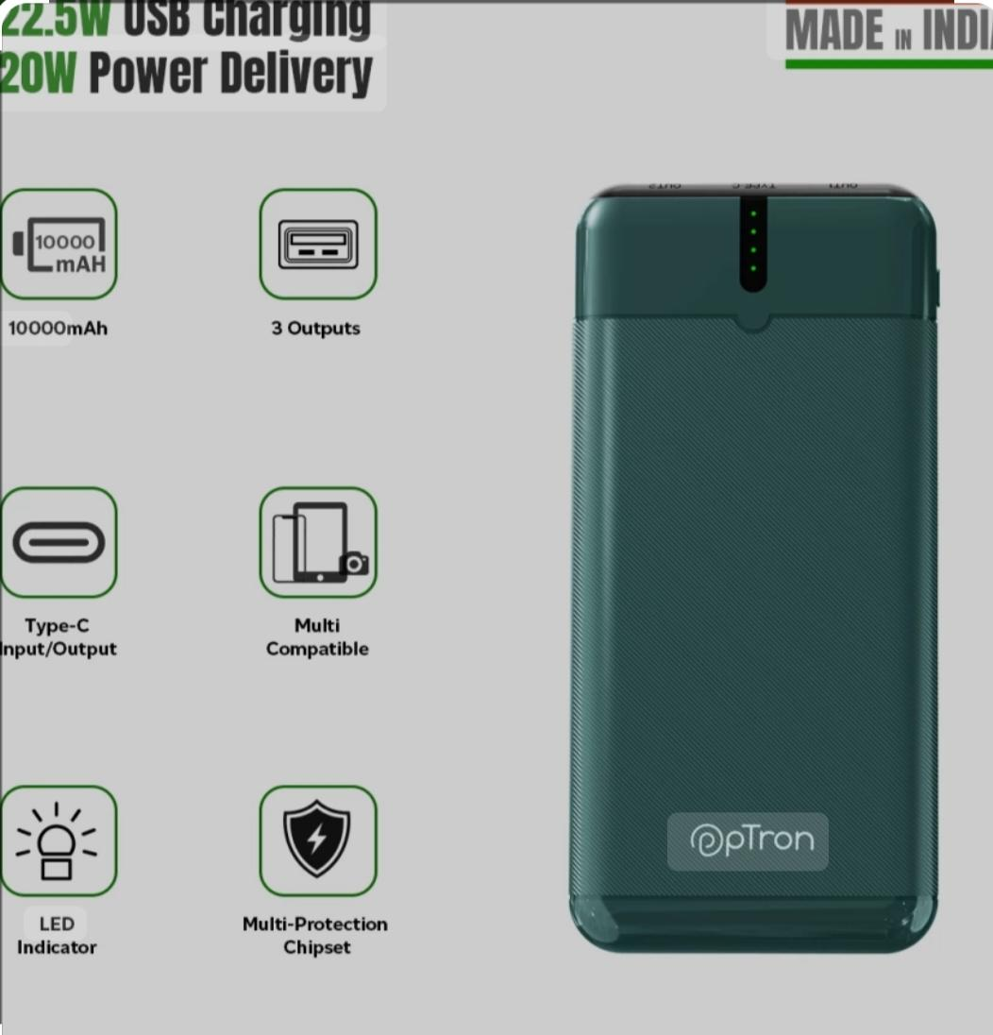

**✓videos:-**

* **Video-1:-** “unboxing and review of ptron latest smartwatch”.
* **Video-2:-** “how to use ptron's wireless earbuds for seamless music streaming”.

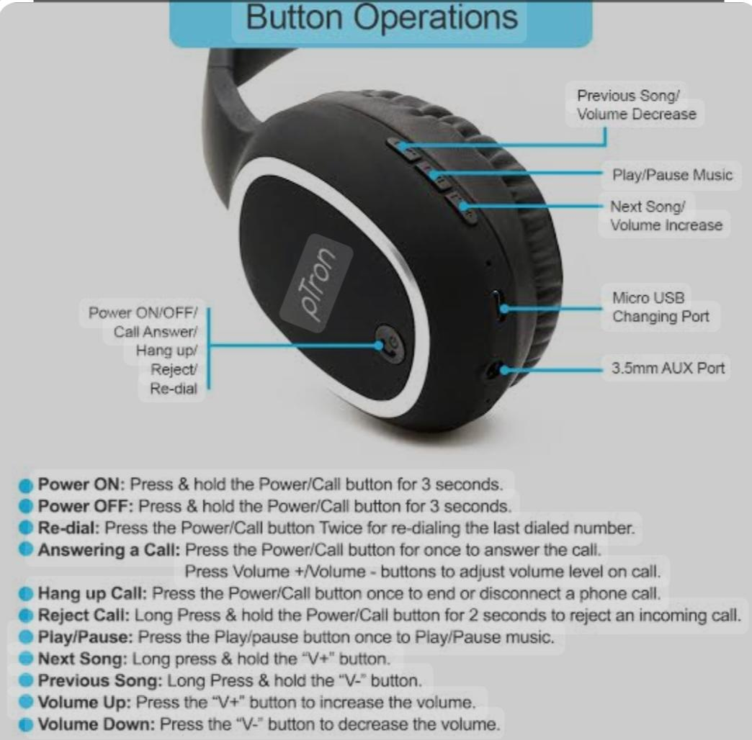

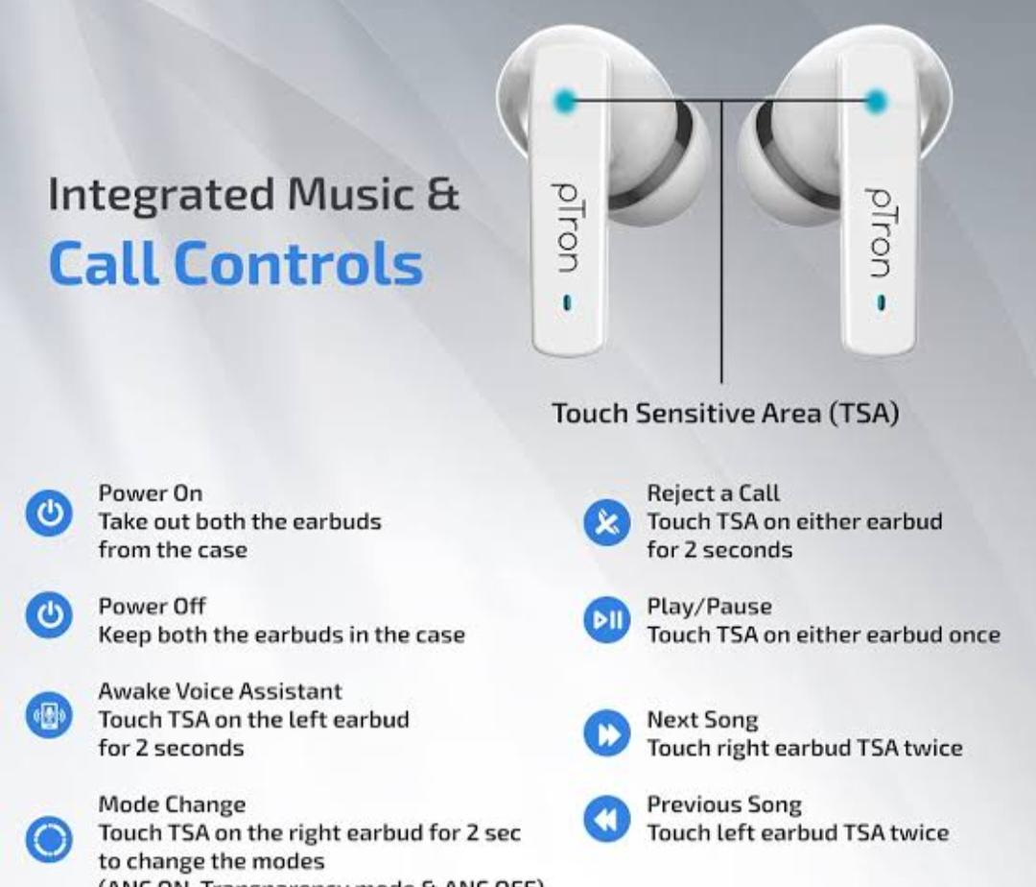

**Content Curation:-**

\***Industry news:-**

* Create news articles from reputable sources on the latest trends in the electronics and accessories industry.
* Share on social media with a brief summary and hashtags #......

**\*User-generated content:-**

* Encourage customers to share photos or videos of themselves using ptron products.
* Curate and share on social media, giving credit to the original creator.

\***Influencer content:-**

* Partner with influencers in the tech and gaming niches to create sponsored content.
* Curate and share on social media, highlighting the influencers experience with ptron products.

***✓post creation:-***

* Used content calendar to plan and schedule posts in advance
* Create engaging captions and hashtags for social media post.

***✓designs / video editing:-***

\***Graphic design:-**

* Create high quality graphics, including logos, icons, an infographics, using Adobe creative cloud.
* Ensure consistency in branding and design across all platforms.



***✓video editing:-***

* Use Adobe premiere Pro or final cut Pro to edit videos, including adding music transitions and effects.
* Ensure videos are optimized for social media platform, including YouTube, Facebook, and Instagram.

***✓social media ad campaigns:-***

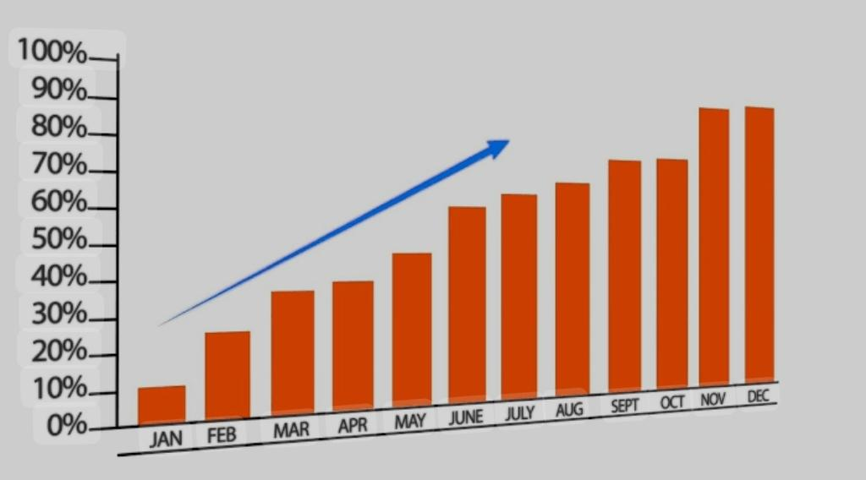

\****Facebook ads:-***

* **Target audience:-** tech savvy individuals aged 18 to 40
* **Ad objectives:-** conversions, lead generation, and brand awareness.
* **Ad creative:-** high quality images and videos showcasing PTron products.

\***Instagram ads:-**

* **Target audience:-** Tech-savvy individuals aged 18 to 40
* **Ad objectives:-** conversions, lead generation, and brand awareness.
* **Ad creative:-** high quality images and videos showcasing PTron products.

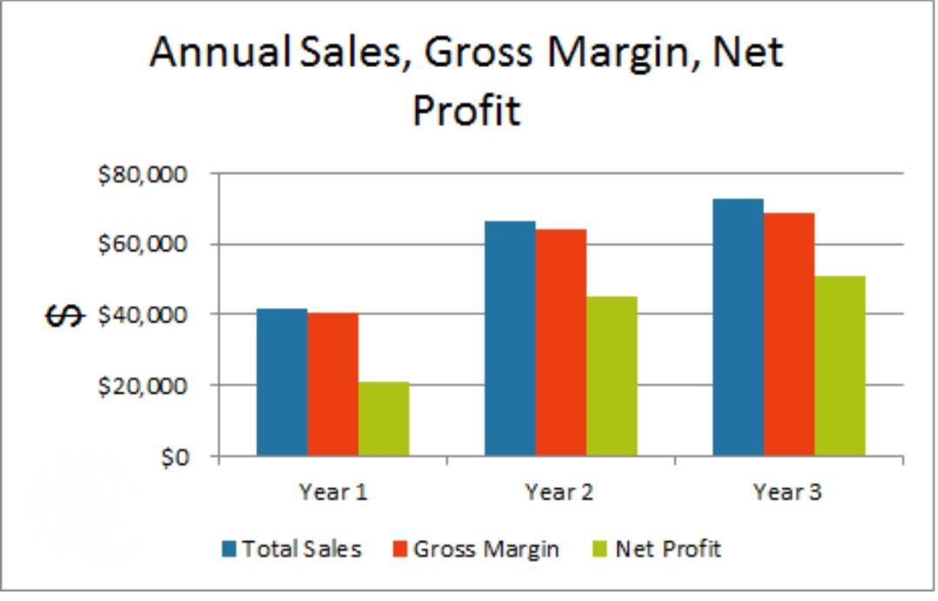

\****Twitter ads:-***

* **Target audience:-** Tech savvy individuals aged 18 to 40.
* **Ad objectives:-** Conversions,lead generation and brand awareness.
* **Ad creative:-** High quality images and videos showcasing PTron products.

***✓Email ad campaigns:-***

\****Welcome email:-***

* **Subject line:-** “welcome to ptron!”.
* **Content:-** introduction to ptron, highlighting products and benefits.
* **Call to action [ CTA]:-** explore our products.

***\*Promotional email:-***

* **Subject line:-** “limited time offer 20% of our best selling products”!
* **Content:-** exclusive promotion, high lighting popular products.
* **CTA:-** shop now and redeem your discount.

***\*Abandoned cart email:-***

* **Subject line:-**”don't miss out! Complete your purchase”.
* **Content:-** reminder about abandoned cart, high lighting products and benefits.
* **CTA:-** complete your purchase now.

*Email Template:-*

Subject:[subject line]

Dear[Name],

[Content]

Best regards,

Ptron team

P.S.[call to action]

[Unsubscribe link].

**\**Thank you\****